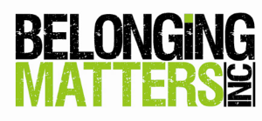
BURSARY APPLICATION FORM

EVENT: Towards a Better Life SRV – Workshop 24 & 25 March 2020

Please note: Due to limited funds Belonging Matters will give preference to People with a Disability and families living within Victoria. Your application must be returned to our office as quickly as possible for our consideration.
Email: info@belongingmatters.org | Fax: 03 9739 8333 | Further Info phone: 03 9739.8333

FIRST NAME | SURNAME

INTEREST eg. Person with a Disability, Family | ORGANISATION NAME (if associated)

POSTAL ADDRESS:
NUMBER |  | STREET/ROAD |  |  |  | TOWN/SUBURB
STATE |  |  |  | COUNTRY |  |  | POSTCODE
PHONE WORK |  |  | PHONE HOME |  | MOBILE
EMAIL

Why are you applying? (please provide details)
□ I have tried to access funding from another agency or CareLink | Please explain
I would like some financial assistance with:
□ Ticket Price
□ Travel | Please explain
□ Accommodation | Please explain
□ Other | Please explain
I am able to contribute something towards my registration:
□ Money | Amount : AUS $
□ I would like to bring someone to assist with personal care | Companion Card number

